1. Write a shell program to perform the addition of two numbers.

echo "Enter the 1st number"

read a

echo "Enter the 2nd number"

read b

S=`expr $a + $b`

echo "The result is:"$S

Bash Script



Output

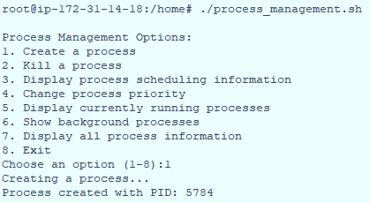

1. Write shell script to show the all-natural numbers from 1 to n ( n is taken from the user ).

read -p "Enter the limit of the series:" n

i=1

echo -n "\nThe realnumber series is:"

while [ $i -le $n ]

do

echo -n " " $i

i=`expr $i + 1`

done

Bash Script



Output



1. Write a shell program to find the maximum number between two number

echo "Ente the 1st number"

read a

echo "Ente the 2nd number"

read b

if [ $a -gt $b ]

then

echo "The greater number is:"$a

else

echo "The greater number is:"$b

fi

Bash Script



Output



1. Write a shell script program to calculate the what is the greater number between three number.

echo "Enter the numbers"

read a b c

if [ $a -gt $b ]

then

if [ $a -gt $c ]

then

echo "The greater number is:"$a

else

echo "The greater number is:"$c

fi

elif [ $a -eq $b -a $b -eq $c ]

then

echo "The number are equal"

else

if [ $b -gt $c ]

then

echo "The greater number is:"$b

else

echo "The greater number is:"$c

fi

fi

Bash Script



Output



1. Write a shell script program to find the number is even or odd.

Output



echo "Enter the number"

read n

s=`expr $n % 2`

if [ $s -eq 0 ]

then

echo "The number is even"

else

echo "The number is odd"

fi

Bash Script



1. Write a shell script to check whether a year is leapyear or not.

Output



echo "Enter the number"

read n

s=`expr $n % 2`

if [ $s -eq 0 ]

then

echo "The number is even"

else

echo "The number is odd"

fi

Bash Script

